REST API
When an application is developed as a web service following are the benefits:
- Integrates with other systems easily
- Creates reusable components
- Cost savings
- Application built using different technologies can interact with each other, for example a Java based application can send data to a.NET application.
As web services provides way for communication between web application
Web Client
A web client is a software using which you can interact with the server where the web application is hosted. The most commonly used web clients are web browsers such as Google Chrome, Mozilla Firefox, Internet Explorer, etc.
Web Server
A web server is a software where the web application is hosted. It processes the request received from the client and sends the response back to the client. It runs on some physical system and listens to client request on a specific port. Apache Tomcat is one of the most widely used web server.
Uniform Resource Locator (URL)
URL stands for Universal Resource Locator. It used by the web client to locate the web server and resource. Every resource on the web has its own unique URL. The following is an example of URL:
http://infy.com:8080/InfyBank/jsps/welcome.jsp
http:// – It is the communication protocol used for server-client communication.
infy.com – It is the hostname of the server that maps to a unique IP address.
8080 – This is the port on which server is listening. It is optional and if not provided request will go to the default port of the protocol.
Hypertext Transfer Protocol (HTTP)
It is a protocol of communication between client and server. A client sends an HTTP request for a resource and the server returns an HTTP response with the desired resource. The HTTP request contains information about the action that the client is requesting the server to perform.
Web Container
Web applications are composed of web components such as servlets, Java Server Page (JSP). These web components get executed to generate content based on client request. So, they need an environment for their execution. This execution environment is called as a web container. Web server takes the help of web container for generating dynamic content. Some commonly used web containers are
- Apache Tomcat
- GlassFish
- Jetty
Application Server
A web application resides in an application server. The application server provides the web application with easy and managed access to the resources of the system. It also provides low-level services, such as the HTTP protocol implementation and database connection management. A web container is just a part of an application server.
Web Services are of two types:
RESTful Web Services
RESTful web services are based on REST principles. As per REST principle everything is a resource.
SOAP based Web Services
SOAP based web services are services that are described, discovered and accessed using standards recommended by W3C
What is REST?
REST stands for REpresentational State Transfer.
REST Principles
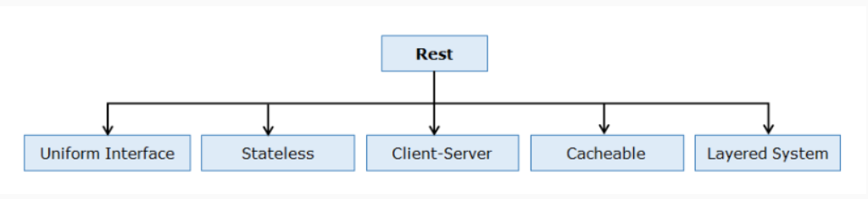

Uniform Interface
In REST anything that can be accessed or manipulated is a resource. For example, "customer", "order", "blog“ all are resources. Every resource has a representation (XML/JSON) and are uniquely identified by a Uniform Resource Identifier (URI). Resources are manipulated using GET, POST, PUT and DELETE methods of HTTP to perform read, create, update and delete of the resource. You can perform different operation on resources using different HTTP methods but with same URI.
Example : If a customer is a resource, then customer details can be added, deleted, updated or retrieved. If a blog is another resource, then the operations we can perform on the blog can be create a blog, read a blog, update a blog or delete a blog.
Difference between URL and URI:
URL | URI
URL is used to describe the identity of an item. | URI provides a technique for defining the identity of an item.
URL links a web page, a component of a web page or a program on a web page with the help of accessing methods like protocols. | URI is used to distinguish one resource from other regardless of the method used.
URL provides the details about what type of protocol is to be used. | URI doesn’t contain the protocol specification.
URL is a type of URI. | URI is the superset of URL.

Stateless
The communication between service consumer (client) and service provider(server) must be stateless between requests. Stateless requires each request from a service consumer to contain all the necessary information for the service to understand the meaning of the request and all session state data should then be returned to the service consumer at the end of each request.
Advantage: Statelessness ensures that each service consumer request can be treated independently by the service.
Stateless Protocol | Stateful Protocol
Stateless Protocol does not require the server to retain the server information or session details. | Stateful Protocol require server to save the status and session information.
In Stateless Protocol, there is no tight dependency between server and client. | In Stateful protocol, there is tight dependency between server and client
The Stateless protocol design simplify the server design. | The Stateful protocol design makes the design of server very complex and heavy.
Stateless Protocols works better at the time of crash because there is no state that must be restored, a failed server can simply restart after a crash. | Stateful Protocol does not work better at the time of crash because stateful server have to keep the information of the status and session details of the internal states.
Stateless Protocols handle the transaction very fastly. | Stateful Protocols handle the transaction very slowly.
Stateless Protocols are easy to implement in Internet. | Stateful protocols are logically heavy to implement in Internet.

Client Server
Client-Server enforces the separation of concerns in the form of a client-server architecture, this helps establish a distributed architecture. This is the most foundational constraint.
Cacheable
Service consumers can cache and reuse response message data. HTTP GET, PUT and DELETE operations are cacheable. RESTful Web Services use HTTP protocol as a carrier for the data, they can use the metadata available in HTTP headers to enable caching. For example: Cache-Control headers are used to optimize caching for enhancing performance.
Layered System
REST based solution can comprise of multiple architectural layers. This constraint builds on client-server wherein we add middleware component(s). Consumer may be communicating with a service residing in a middleware layer or the actual provider. A service does not need to be aware of whether its consumer is further communicating with other services or acting as a provider for another consumer.
What is RESTful Web Service?
Any web service which satisfies REST principles is called RESTful web service. These web services are usually exposed to third‐party applications as application programming interface (API). Popular sites such as Facebook, Twitter, and LinkedIn offer REST web services for accessing stored data.
REST URI Templates
When creating REST API's, you need to represent the structure of a URI rather than the URI itself. For example, in InfyBank application, the URI http://infybank.com/customers/2001 would fetch details of the customer whose id is 2001. Similarly, the URI http://infybank.com/customers/2002 would fetch details of the customer whose id is 2002. In this scenario structure of URI is important. URI templates provide a standard way for describing structure of URI. The URI template for this scenario could be:
- http://infybank.com/customers/{customerid}
The curly braces {} indicate that the customerId part of the template is a variable, often called as a path variable. The clients consuming the web service can take this URI template as input, retrieve the value of path variable, and use it to retrieve the corresponding customer details.
What does State Transfer mean?
When you make a request to a resource like http://www.infy.com/employees/john using HTTP, we may be asking for the current "state" of this resource or its desired "state". You can use the same URI to indicate that, we want to:
Retrieve the current value of an Employee John (current state)
Perform Update operation on employee John's data (desired state) etc.
The server will understand which operation has to be invoked based on the HTTP method that was used to make a call. In short it means that a client and server exchange, representation of a resource, which reflects its current state (GET) or its desired state (PUT).
Level 0
This is the basic level for a REST based web service. In this level single URI is used to expose the entire API. It uses a single HTTP method (typically POST or GET) to make remote procedure call on a single URI to perform operation on resources. SOAP based and XML RPC based web services comes in this level.
Level 1
The services in this level have multiple URI's for every resource but uses only one HTTP method – generally POST – to perform all the operations. Since specific resource is identified by a unique URI services in this level are closer to REST principles than services in level zero.
Level 2
The services in this level uses HTTP protocol and its methods and status codes along with URI’s to perform all the operations. For example, to get the employees, we send a GET request with the URI /employees, and the server sends proper response 200 OK and to add a customer, we send a POST request with the URI /employees, and the server sends proper response 201 CREATED. Services which implements CRUD operations are Level 2 services.
Level 3
This is the most mature level for a service. It is the combination of Level 2 and HATEOAS (Hypermedia as the Engine of Application State). Services in this level provides responses with links to related resources and controls which tells service client what to do next.

Spring Boot by default reads the static resources such as HTML pages, CSS, Java script, images, etc. present in following locations in classpath:
- /static
- /public
- /resources
- /META-INF/resources
During application development, you might need to change code many times and for these changes to reflect in application, the application needs to be restarted. Spring Boot provides developer tools using which you can automate this process. To use developer tools, add Spring Boot Dev Tools dependency while creating Spring Boot project. It adds following dependency in pom.xml file:
- <dependency>
- <groupId>org.springframework.boot</groupId>
- <artifactId>spring-boot-devtools</artifactId>
- <optional>true</optional>
- </dependency>

@RestController
This annotation is used to define REST controllers. It is a combination of @Controller and @ResponseBody annotation. @Controller annotation marks a class for discovery by component scanning. @ResponseBody tells Spring that all handler methods in the controller should have their return value written directly to the body of the response, rather than being carried in the model to a view for rendering.
@RequestMapping
This annotation is used to map the HTTP requests to handler methods of REST controllers. You can use it at class-level or method-level in a controller. The class-level @RequestMapping specifies that any handler methods in this controller will handle requests with specific request path or pattern while method-level makes mappings more specific to handler methods. By default, this annotation matches to all HTTP methods. But usually controller methods should be mapped to a specific HTTP method. For this, you can use method attribute in this annotation. For example, to map an HTTP POST request you can use this annotation as follows:
- @RequestMapping(method=RequestMethod.POST)
Spring 4.3 introduced new annotations for mapping handler methods with specific HTTP requests. These methods are as follows:
- @GetMapping
- @PostMapping
- @PutMapping
- @DeleteMapping
@GetMapping
This annotation handles HTTP GET request. In CustomerAPI when an HTTP GET request is received for infybank/customers, getAllCustomerDetails() will be called so @GetMapping is used as follows:
- @GetMapping(value="/customers")
The return type of getAllCustomerDetails() method is ResponseEntity. ResponseEntity represents the entire HTTP response which includes HTTP response code, response body and response headers. In method implementation, details of all the customers are fetched using CustomerService and then an instance of ResponseEntity is created with customer data and the HttpStatus.OK status code as follows:
- ResponseEntity<List<Customer>> response = new ResponseEntity<List<Customer>>(customerList, HttpStatus.OK);
@PathVariable
This annotation is used to extract values from URI template into a method parameter. It indicates that a method parameter should be bound to a URI template variable [the one in '{}']. In getCustomerDetails() method, the value attribute of GetMapping annotation takes URI template /customers/{customerId} as parameter where the {customerId} portion of the path is a placeholder. The actual value in the request is given to the customerId parameter, which is mapped to the {customerId} placeholder by @PathVariable. So when HTTP GET request is received for infybank/customers/1 then details of only that customer whose customerId is 1 is fetched.
Note that the path variable name and the parameter name should match. If you want to use a different parameter name, then you could specify the path variable name in the annotation as follows:
- @GetMapping(value = "/customers/{customerId}")
- public ResponseEntity<Customer> getCustomerDetails(@PathVariable(value="customerId") Integer custId) throws InfyBankException{
- //rest of the code
- }
You can also use @PathVariable("customerId") or @PathVariable(name="customerId"). This annotation can be used in any type of request method (GET, POST, DELETE, etc).
@PostMapping
This annotation handles HTTP POST request. In CustomerAPI when an HTTP POST request is received for infybank/customers, then addCustomer() method will be called so @PostMapping is used as follows:
- @PostMapping(value = "/customers")
- public ResponseEntity<String> addCustomer(@RequestBody Customer customer) throws InfyBankException{
- //rest of the code
- }
You know that along with the POST request we have to send customer data. For this customer parameter of addCustomer() method is annotated with @RequestBody annotation. It ensures that JSON data about customer in the request body is converted to a Customer object.
@PutMapping
This annotation handles HTTP PUT request. In CustomerAPI when an HTTP PUT request is received for infybank/customers/{customerId}, then updateCustomer() method will be called so @PutMapping is used as follows:
- @PutMapping(value = "/customers/{customerId}")
- public ResponseEntity<String> updateCustomer(@PathVariable Integer customerId, @RequestBody Customer customer) throws InfyBankException{
- //rest of the code
- }
@DeleteMapping
This annotation handles HTTP DELETE request. In CustomerAPI when an HTTP DELETE request is received for infybank/customers/{customerId}, then deleteCustomer() method will be called so @DeleteMapping is used as follows:
- @DeleteMapping(value = "/customers/{customerId}")
- public ResponseEntity<String> deleteCustomer(@PathVariable Integer customerId) throws InfyBankException{
- //rest of the code
- }
@RequestParam
So far you have learned that using path variable you can extract values from URI template. But sometimes the request contains information as query string. A query string in part of URL and contains key-value pair. For example, consider the following URL:
- http://localhost:8080/infybank/customers?customerId=1234&name=Smith
In above URL customerId=1234&name=Smith is query string with key customerId and name. The value of cutomerId is 1234 and value of name is Smith.
Using @RequestParam annotation you can bind values of query string to the controller method parameters. For example following handler method is mapped with the request /customers?customerId = 12345 :
- @GetMapping(value = "/customers")
- public ResponseEntity<String> getCustomer(@RequestParam Integer customerId) throws InfyBankException{
- //rest of the code
- }

So far, you have learnt how to create REST services that can be consumed by some other applications but sometimes, you need to consume REST APIs using Spring application. For this, Spring provides RestTemplate class. It takes care of the necessary plumbing needed to communicate with REST API's and automatically marshals/unmarshals HTTP request and response bodies and provides methods for interacting with REST resources. To use RestTemplate, you need to create its object as follows:
- RestTemplate restTemplate = new RestTemplate();
or you can declare it as a bean and inject it where you need it.
- @Bean
- public RestTemplate restTemplate(){
- return new RestTemplate();
- }
Handling HTTP GET
Suppose that you want to fetch details of customer based on customer id. For this you can make an HTTP GET request using getForObject() method of RestTemplate class as follows:
- public void getCustomerDetails(Integer customerId) {
- String url = "http://localhost:8765/infybank/customers/{customerId}";
- RestTemplate restTemplate = new RestTemplate();
- CustomerDTO customerDTO = restTemplate.getForObject(url, CustomerDTO.class, customerId);
- }
In above code snippet, the getForObject() sends an HTTP GET request using specified URL and an object mapped from a response body. The first parameter is the URL. The second parameter is type of response. In this case, the response data which is in JSON format is deserialized into Customer object and that will be returned. The third parameter is used to fill in the {customerId} placeholder in the given URL.
Handling HTTP POST
Suppose you want to add new customer to database. For this you can make an HTTP POST request using postForObject() method of RestTemplate class as follows:
- public void addCustomer(CustomerDTO customer) {
- String url = "http://localhost:8765/infybank/customers";
- RestTemplate restTemplate = new RestTemplate();
- String response = restTemplate.postForObject(url, customer, String.class);
- LOGGER.info(response);
- }
In above code snippet, the postForObject() method POST's data to a URL and returns an object mapped from the response body The first parameter is the URL, second parameter is object to be posted to the server and third parameter is type of return value.
Handling HTTP PUT
Suppose you want to update details of a customer from database based on customerId. For this you can make an HTTP PUT request using put() method from RestTemplate as follows:
- public void updateCustomer(CustomerDTO customerDTO) {
- String url = "http://localhost:8765/infybank/customers/{customerId}";
- RestTemplate restTemplate = new RestTemplate();
- restTemplate.put(url, customerDTO, customerDTO.getCustomerId());
- LOGGER.info("Customer updated successfully");
- }
Handling HTTP DELETE
Suppose you want to delete a customer from database based on customerId. For this you can make an HTTP DELETE request using delete() method of RestTemplate class as follows:
- public void deleteCustomer(Integer customerId) {
- String url = "http://localhost:8765/infybank/customers/{customerId}";
- RestTemplate restTemplate = new RestTemplate();
- restTemplate.delete(url, customerId);
- LOGGER.info("Customer deleted successfully");
- }

For security reasons, browsers don’t allow you to make cross-origin request. Cross origin requests are requests to those resources which resides outside the current origin. For example, if a document served from xyz.com makes a request to domain abc.com for some images then this request is called as cross origin request.
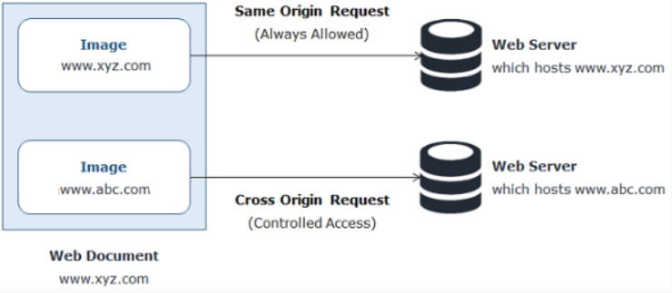
To allow cross-origin requests, Cross-Origin Resource Sharing (CORS) is used. It is an specification which provides a way to specify which cross-origin requests are permitted. Spring provides @CrossOrigin annotation for enabling CORS for REST API so that the API clients can make calls to REST APIs. This annotation can be applied at class level as follows:
- @CrossOrigin
- @RestController
- public class CustomerController{

- }
When applied at the class level, the same @CrossOrigin configuration is applied to all the @RequestMapping methods.
@RequestMapping annotation by default handles all types of HTTP requests
@ResponseBody annotation indicates that value returned by a method is bound to body of HTTP response.
Option @RequestMapping(value = "/customer/{custId}", method = RequestMethod.GET) is Correct
Explanation :
Yes. You are correct.
@ReuestMapping annotation can also be used to map a method of controller with URI. The name of path variable is also correct.
Option http://localhost:8080/api/customer?customerId=1001 is Correct
Explanation :
Yes. You are correct.
customerId is request parameter so the format of URL is correct. So, this option is correct.
RestTemplate needs to be configured as Spring bean for being autowired.

- @RestController
- @RequestMapping(value="/infybank")
- public class CustomerAPI {

- @Autowired
- private CustomerService customerService;

- @GetMapping(value = "/customers/{customerId}")
- public ResponseEntity<Customer> getCustomerDetails(@PathVariable Integer customerId) throws Exception {
- ResponseEntity<Customer> response = null;
- try {
- Customer customer = customerService.getCustomer(customerId);
- response = new ResponseEntity<Customer>(customer, HttpStatus.OK);
- } catch (Exception exception) {
- return new ResponseEntity<>(HttpStatus.NOT_FOUND);
- }
- return response;
- }
- }
But this solution adds more code to the controller and makes it complex. Also if multiple handler methods are present in controller, then this code you may have to repeat in all those methods. Also, there is no way to send more detailed description of exception to the client. So proper exception handling in REST API's is very important. Spring provides multiple ways of exception handling in REST API. In this course, you will learn following two ways of exception handling:
- Using @RestControllerAdvice
- Using ResponseStatusException class
You can also have multiple handler methods in the Advice class to handle exceptions of different types and return the response accordingly. For example, to handle all types of exception you can also add a general exception handler method as follows:
- @RestControllerAdvice
- public class ExceptionControllerAdvice {

- @Autowired
- private Environment environment;

- @ExceptionHandler(Exception.class)
- public ResponseEntity<String> exceptionHandler(Exception exception) {
- return new ResponseEntity<>(environment.getProperty("General.EXCEPTION_MESSAGE"), HttpStatus.INTERNAL_SERVER_ERROR);
- }

- @ExceptionHandler(InfyBankException.class)
- public ResponseEntity<String> infyBankExceptionHandler(InfyBankException exception){
- return new ResponseEntity<>(environment.getProperty(exception.getMessage()), HttpStatus.NOT_FOUND);
- }
- }

Spring 5 introduced the ResponseStatusException class. This is a base class for exceptions associated with specific HTTP status codes. You can create an instance of it by providing an HttpStatus code, a message to explain the exception and cause of the exception as follows:
- @GetMapping(value = "/customers/{customerId}")
- public ResponseEntity<CustomerDTO> getCustomer(@PathVariable Integer customerId) throws InfyBankException {
- try {
- CustomerDTO customerDTO = customerService.getCustomer(customerId);
- return new ResponseEntity<>(customerDTO, HttpStatus.OK);
- } catch (Exception exception) {
- throw new ResponseStatusException(HttpStatus.NOT_FOUND, environment.getProperty(exception.getMessage()), exception);
- }
- }

You see that the customer details get added with incorrect email id. There are many such situations where the client may send request with missing data or data in invalid format. In such situations if input data is not validated then it gets processed. This sometimes makes your data in database inconsistent. So, input data must be validated before being processed. You can do this manually in-service class. But Spring provides support for user input validation through Bean Validation API which simplifies the input validation. In this course, you will learn how to use Bean Validation API for input validation.

- UsernamePasswordAuthenticationFilter: It performs the task of authentication.
- AnonymousAuthenticationFilter: It performs anonymous authentication. If authentication credentials are not present in request it creates an anonymous user. These users are allowed to access API"s which does not require authentication.
- ExceptionTranslationFilter: It translates security exceptions to a proper HTTP response.
- FilterSecurityInterceptor: It performs authorization of resources.
To use Spring Security in a Spring Boot application add the following dependency in pom.xml file:
- <dependency>
- <groupId>org.springframework.boot</groupId>
- <artifactId>spring-boot-starter-security</artifactId>
- </dependency>
On seeing this dependency in classpath, Spring Boot configures default security configuration for whole application. It provides following security features:
- All requests will be authenticated using HTTP basic authentication.
- The credentials for accessing the application will be automatically generated with only one user. There is no specific roles or authorities assigned to user. The default user name is user, and the default password is generated in a random fashion during the application start. You can get this password from the console log of the application as shown below:

To create custom security configuration class you have to extend WebSecurityConfigurerAdapter class and annotate it with @EnableWebSecurity annotation as follows:
- @EnableWebSecurity
- public class SecurityConfig extends WebSecurityConfigurerAdapter {
- //rest of the code
- }
In above code,
- @EnableWebSecurity enables web security support provided by Spring Security.
- WebSecurityConfigurerAdapter class provides methods which has to overridden to implement custom security requirements.
For this Spring Security provides encoders which implements PasswordEncoder interface. One of the encoders is BCryptPasswordEncoder which we will use. To use this, configure following bean in SecurityConfig class:
- PasswordEncoder passwordEncoder() {
- return new BCryptPasswordEncoder();
- }
In above code,
- authorizeRequests() method returns an object of ExpressionInterceptUrlRegistry using which URL paths and their security requirements are specified.
- The Spring security by default enables CSRF(Cross Site Request Forgery) protection. Because of this you can access only GET endpoints. For accessing PUT, POST and DELETE endpoints, you have to disable the CSRF protection. So this is disabled usign the below code:
  - http.csrf().disable();
Note: Instead of disbaling CSRF you can also send CSRF token along with the request which is beyond the scope of this course. CSRF is disabled usually if REST API is consumed by non-browser based REST clients.
To authorize requests to URI infybank/customers only to users having ADMIN role you can override this method as follows:
- protected void configure(HttpSecurity http) throws Exception {
- http
- .authorizeRequests()
- .antMatchers("/infybank/customers/**")
- .hasRole("ADMIN")
- .anyRequest()
- .authenticated()
- .and()
- .httpBasic();
- http.csrf().disable();
- }
In above code,
- The URI to be protected is mentioned using antMatchers() method. In URI "/infybank/customers/**", ** means any value after /infybank/customers.
- the hasRole() method specifies the role of the user.
- anyRequest().authenticated() means any request mapped to this URI will be authenticated.
- httpBasic() specifies that HTTP basic authentication has to be used.
You can also specify the HTTP method along with the URI as follows:
- protected void configure(HttpSecurity http) throws Exception {
- http
- .authorizeRequests()
- .antMatchers(HttpMethod.POST, "/infybank/customers/**")
- .hasRole("CUSTOMER")
- .anyRequest()
- .authenticated()
- .and()
- .httpBasic();
- http.csrf().disable();
- }
In above code,
- The users with role CUSTOMER can access only the POST endpoint with URI "/infybank/customers/**".
Microservices
Consider an online shopping application with the following functionalities:
- Search products
- Place order
- View all orders
The most common approach to develop this application is to implement all these functionalities in a single application. This application is then deployed as one application for all different types of users. This type of architecture where all the functionalities are implemented in one single application is called as Monolithic Architecture. In this architecture the application is divided into different layers. Some common layers in this architecture are as follows:
- Presentation Layer — It responsible for handling HTTP requests and sending response.
- Service Layer — In this layer business logic of the application is implemented.
- Persistence layer — In this layer logic for accessing the database is implemented.
The applications developed using this architecture are easy to develop, test and deploy. However, there are certain issues that tag along with monolithic applications. As the application becomes larger and complex, we will face difficulties in the following aspects:
- Deployment will take a long time.
- Scalability is an issue as it is not possible to scale any single functionality alone. For example, the 'Search' functionality maybe used more often than the 'Book' functionality. Hence, we would like to scale the 'Search' functionality and not the 'Book' functionality. This is not possible when we go with the monolithic approach.
- Failure of a single functionality will lead to failure of entire application in monolithic architecture.
- New technologies or frameworks cannot be used in the existing application. If new technology is needed, then complete re-write must be done.
- It is not very reliable as a single bug in any module can bring down the entire application.
How do we resolve these issues?
The answer is Microservices. It is another architecture of application development.
Parameter | Monolithic | Microservice
Development | Needs to be developed in a single language | Each service can be written in different languages
Testing | For any change, the entire application needs to be tested again | Only the modified service needs to be tested again
Runtime | Monolithic application runs as a single process | Each service runs its own process
Packaging | Packaged as a single JAR/WAR file | Each service is packaged as single JAR/WAR file
Scalability | Entire application needs to be scaled or replicated on multiple servers | Only the service that requires scaling, can be scaled
Minor Changes | For any modification. entire application needs to be re-built and re-deployed | Only the modified service needs to be re-built and re-deployed
The following are the top reasons for choosing Microservice architecture:
- Easy deployment: A large code base will make the IDE slow and build time increases. In Microservice architecture, each project is independent and small in size. So overall build and development time gets reduced.
- Small teams: Microservices have single-purpose design, which means they can be built and maintained by smaller teams. Moreover, each team can be cross-functional i.e each team can have their own developers, testers and operations team and can be responsible for a single microservice.
- Loose coupling: It extremely difficult to change technology or language or framework when everything is tightly coupled and dependent on each other. In microservices, it is easy to change technology or framework because every module and project is independent and loosely coupled.
- Domain-driven design: Although microservices are supposed to be small in size, it is not the only criteria. The services should have well-defined boundaries centered around business requirements. Domain-driven design, helps design software systems based on the underlying model of the business domain, which is the requirement of microservices.
If we look at the evolution of software, we started with unstructured code. Then we moved on to packages for codes, which slowly moved on to creating libraries for reuse. Then we had multiple applications and multiple libraries which had services added to them.
Although microservices have advantages, there are a few disadvantages as well. The following are the disadvantages of using microservices.
- Performance: As we have a more distributed and complex application, performance could be affected.
- Maintenance: An application can have hundreds of microservices and maintaining all of them can be a challenge. This can be overcome by de-centralized management.
- Infrastructure: Initially, microservices require a huge infrastructure setup.
- Cost: Due to huge infrastructure setup huge cost may also be incurred. Also, services need to communicate with each other. This can increase network latency and processing costs.

APPENDIX
Spring Boot has an in-built mechanism for monitoring application called as Actuator. It is a sub-project of Spring Boot. It offers several production grade features to monitor the application. Once you enable actuator in your Spring Boot application, a set of endpoints are exposed using which you can monitor and manage your application. You can also integrate these endpoints with other application monitoring tools such Prometheus, Graphite etc.

Actuator Endpoints
Once Actuator is enabled in your application, using actuator endpoints you can monitor and manage your application. These endpoints are exposed over HTTP in Spring MVC application using the 'id' of endpoints as the URL path along with /acuator as prefix. The following table shows some important actuator endpoints :
id | Description
/beans | Provides list of all Spring beans available in the application
/configprops | Provides a collated list of all @ConfigurationProperties
/env | Exposes all the properties fromSpring's ConfigurableEnvironment
/info | Displays arbitrary application information
/metrics | Displays metric information for the current application
/mappings | Displays a collated list of all request mapping paths
/shutdown | Allows the application to shutdown
/trace | Displays trace information, by default latest 100 HTTP requests
/health | Provides applications health information
These endpoints contain sensitive information so all of them are not exposed by default. Only /health and /info endpoints are exposed by default. You can enable all other endpoints by adding following property in the application.properties file:
- management.endpoints.web.exposure.include=*
You also restrict the exposure of specific endpoint. For example, to expose all endpoints except env add the the following property in application.properties file:
- management.endpoints.web.exposure.include=*
- management.endpoints.web.exposure.exclude=env
Any specific endpoint can be exposed as shown below:
- management.endpoints.web.exposure.include=env,beans
​In Spring Boot you can easily customize existing Actuator endpoints and can also create new endpoints. To create a new endpoint you have to create a class and annotate it with @Component and @Endpoint annotation. The @Endpoint annotation has a parameter id which determines the URL path of endpoint. This class contains the methods which returns the response of the endpoint. For example, consider the following endpoint bean class:
- @Component
- @Endpoint(id = "customers")
- public class MyCustomerEndpoint {

- @ReadOperation
- public List<CustomerDTO> getAllCustomers(){
- // rest of the code
- }

- @WriteOperation
- public String updateCustomer(Integer customerId, String emailId) throws InfyBankException {
- // rest of the code
- }

- @DeleteOperation
- public String deleteCustomer(@Selector Integer customerId) {
- // rest of the code
- }
- }
In above class,
- The value of id parameter of @Endpoint is customers. So, this endpoint is accessible by URL /actuator/customers.
- a method defined with @ReadOperation which will be mapped to HTTP GET method and automatically be exposed over HTTP.
- a method defined with @WriteOperation which will be mapped to HTTP POST method and automatically be exposed over HTTP. The methods that are annotated with @WriteOperation can take parameters in JSON format alone.
- a method defined with @DeleteOperation which will be mapped to HTTP DELETE method and automatically be exposed over HTTP.
- technology-specific endpoints defined with @WebEndpoint/@JmxEndpoint. For ex, @WebEndpoint is exposed over HTTP only.

Hatheos
But how can we make a REST API to work like a website i.e. how we can add hyperlinks to other resources. For this HATEOAS is used.
HATEOAS (Hypermedia as the Engine of Application State) is a constraint of REST application architecture. With HATEOAS you can develop REST API which generates response containing hypermedia links to other resources using which the client can navigate through the API dynamically. Hypermedia means any content that has links to other media such as text, images, videos.
HAL (Hypermedia Application Language)
You know that hypermedia is a media type that contains links to other resources. But JSON is not a hypermedia type because is does not provide standard way for hyperlonking of resources. So, many JSON hypermedia types are created with provides way to add hyperlink in JSON document. HAL (Hypermedia Application Language) is one of the most popular JSON hypermedia type. It is also supported by Spring Framework. A resource in HAL contains following things:
1. State : It is the actual data of the resource in JSON format. The following code shows state of customer resource:
- {
- "customerId": 2,
- "emailId": "tim@infy.com",
- "name": "Tim",
- "dateOfBirth": "2007-01-08"
- }
2. Links : It is a collection of links. In HAL _links propery is used to add links to other resources. It is a JSON object. The following code shows customer resource with _links property:
- {
- "customerId": 1,
- "emailId": "martin@infy.com",
- "name": "Martin",
- "dateOfBirth": "1996-01-26",
- "_links": {
- "self": {
- "href": "http://localhost:8765/infybank/customers/1"
- }
- }
- }
3. Embedded Resources : It is other resources contained inside the resource rather link to that particular resource. In HAL _embedded propery is used to embed resources.

- @RestController
- @RequestMapping(value = "/infybank")
- public class CustomerAPI {

- @Autowired
- private CustomerService customerService;

- @Autowired
- private Environment environment;

- @GetMapping(value = "/customers/{customerId}")
- public EntityModel<CustomerDTO> getCustomer(@PathVariable Integer customerId) throws InfyBankException {
- CustomerDTO customer = customerService.getCustomer(customerId);
- Link selfLink = linkTo(methodOn(CustomerAPI.class).getCustomer(customerId)).withSelfRel();
- Link customersLink = linkTo(methodOn(CustomerAPI.class).getAllCustomers()).withRel("customers");
- //customer.add(selfLink);
- return EntityModel.of(customer,selfLink,customersLink);
- }

- @GetMapping(value = "/customers")
- public CollectionModel<EntityModel<CustomerDTO>> getAllCustomers() throws InfyBankException {
- List<EntityModel<CustomerDTO>> customers = customerService.getAllCustomers().stream().map(
- customer->EntityModel.of(customer, linkTo(methodOn(CustomerAPI.class).getCustomer(customer.getCustomerId())).withSelfRel())).collect(Collectors.toList());
- Link link = linkTo(methodOn(CustomerAPI.class).getAllCustomers()).withRel("customers");
- return CollectionModel.of(customers, link);
- }
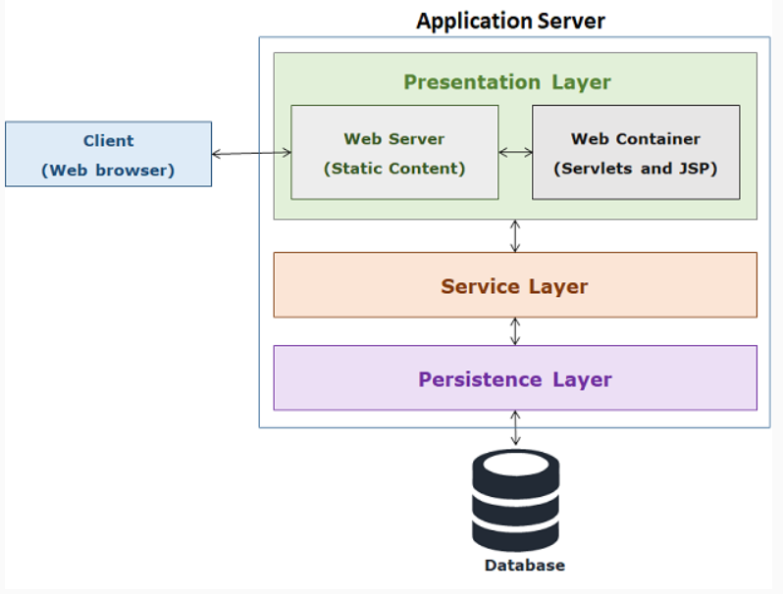

The browser sends requests to the web server. If the target is static content, the server handles it directly. If the target is a dynamic content, the server delegates the request to web container which in turn forwards it to web components such as servlets and JSP. These web components interact with service and persistence layer to generate the dynamic content. Once the dynamic content is generated web server sends it back to the client.

Servlet API is a set of classes and interface required for developing servlets. These classes and interfaces are defined in the following two packages:
- javax.servlet - It contains classes and interfaces which are protocol independent.
- javax.servlet.http - It contains classes and interfaces which are HTTP specific implementation.
Servlet interface
This interface provides common behavior to all the servlets. It defines methods that all servlets must implement. It is present in javax.servlet package and contains the following methods:
- public void init(ServletConfig config) - This method is used to initialize a servlet object.
- public void service(ServletRequest request,ServletResponse response) - This method is used to handle the incoming request and generate the necessary dynamic content. These requests are dispatched to the appropriate request handling method by the service() method.
- public void destroy() - This method is used to perform a set of activities before removal of the servlet object.
GenericServlet class
GenericServlet class implements the Servlet interface which can be used for generating response independent of the protocol involved. It provides implementation of init() and destroy(), however service() is left abstract.
HttpServlet class
This class extends GenericServlet class and is used for generating response for HTTP protocol. It provides specific methods to handle HTTP method specific requests. Some important methods of this class are :
- doGet(HttpServletRequest req, HttpServletResponse res) - It handles the HTTP GET request.
- doPost(HttpServletRequest req, HttpServletResponse res) - It handles the HTTP POST request.
- doPut(HttpServletRequest req, HttpServletResponse res) - It handles the HTTP PUT request.
- doDelete(HttpServletRequest req, HttpServletResponse res) - It handles the HTTP DELETE request.
Defining Servlet
To define a Java class as a servlet you can extend either GenericServlet or HttpServlet class. If you are extending GenericServlet then you have to provide the implementation for the service() method and if you are extending HttpServlet class then you have to override the implementation of doPost(), doGet(), etc. methods.
Servlet Mapping using Annotation
When a web container receives a request from a client it must invoke the appropriate servlet depending on the URL of the request. To locate appropriate servlet web container uses servlet mapping. Servlet mapping specify which URL patterns should be handled by which servlet. From Servlet API 3.0, this mapping can be done using @WebServlet annotation. The following code snippet maps the LoginServlet class with /LoginServlet request path.
- @WebServlet("/LoginServlet")

- public class LoginServlet extends HttpServlet{

- //rest of the code

- }

JSP
Java Server Pages is the scripting language which is used to create dynamic web pages in Java. A JSP page is a web page that contains Java code along with the HTML tags. When accessed by a client, the Java code within the page is executed on the server side, producing textual data. This data, which is surrounded by HTML tags, is sent as a normal HTML page to the client. Since the Java code embedded in a JSP page is processed on the server side, the client has no knowledge of the code. The code is replaced by the HTML generated by the Java code before the page is sent to the client.
Creating JSP pages
To create a JSP page, JSP elements also called as JSP tags are used to manipulate Java objects and perform operations upon them to generate dynamic content. Some of these elements are as follows:
Declarations
These are used to declare and define variables and methods in the JSP page. These are converted to instance variables and methods of the servlet. Its syntax is as follows:
- <%! variable and method declaration %>
Scriptlets
It contains Java code to be executed, these codes are added to service() method of the servlet during translation. Its syntax is as follows:
- <% Java code to be executed %>
Expressions
These are Java expressions which are evaluated and result is inserted as text in the response to be delivered. Its syntax is as follows:
- <%= some expression %>
The following code snippet shows the use of a declaration, scriptlet and expression:
- <%!

- public String display() {

- String message = "Welcome to JSP";

- return message;

- }

- %>

- Message from <b>Scriptlet</b>: <%display();%><br/>

- Message from <b>Expression</b>: <%=display() %>
In above code snippet lines 1 to 6 contain a JSP declaration that declares a display() method. In line 7 the display() method is called.
Modify the index.jsp page in webapp folder with following content:
- <!DOCTYPE html>

- <html>

- <head>

- <meta charset="ISO-8859-1">

- <title>InfyBank Login</title>

- </head>

- <body>

- <div align='center'>

- <h2>Welcome to InfyBank</h2><br />

- <form action="CustomerLogin.jsp">

- <label>UserName:</label>

- <input type="text" name="loginName"/><br/><br/>

- <label>Password:</label>

- <input type="password" name="password"/><br/><br/>

- <input type="submit" value="Submit"/>

- </form>

- </div>

- </body>

- </html>

- Create customerlogin.jsp file in webapp folder with following content:

- <%@ page language="java" contentType="text/html; charset=ISO-8859-1"

- pageEncoding="ISO-8859-1"%>

- <!DOCTYPE html PUBLIC "-//W3C//DTD HTML 4.01 Transitional//EN" "http://www.w3.org/TR/html4/loose.dtd">

- <html>

- <head>

- <meta http-equiv="Content-Type" content="text/html; charset=ISO-8859-1">

- <title>InfyBank Login</title>

- </head>

- <body>

- <%-- page directive used for importing CustomerLogin and CustomerLoginServiceImpl classes --%>

- <%@ page import="com.infy.model.CustomerLogin,com.infy.service.CustomerLoginServiceImpl"%>

- <%

- CustomerLogin customerLogin = new CustomerLogin();

- customerLogin.setLoginName(request.getParameter("loginName"));

- customerLogin.setPassword(request.getParameter("password"));

- CustomerLoginServiceImpl customerLoginService = new CustomerLoginServiceImpl();

- String message = customerLoginService.authenticateCustomer(customerLogin);

- if (message.contains("success")){

- %>

- <h3 align="center">

- <%="Welcome " + request.getParameter("loginName") + "."%>

- <br>You have successfully logged in.

- </h3>

- <%

- } else {

- %>

- <h3 align="center">Invalid credentials, Please try again.</h3>

- <%

- }

- %>

- </body>

- </html>

MVC ARCHITECTURE

If you develop a single component that interacts with the user as well as maintains the database, then a new requirement will lead to the redesign of the component. So instead of having a single component, you can split it into three different components. This separation of concerns makes code more organized and maintainable. For this there is an architectural pattern called Model View Controller (MVC). This pattern separates architecture into their components called Model, View, and Controller which can communicate with each other.

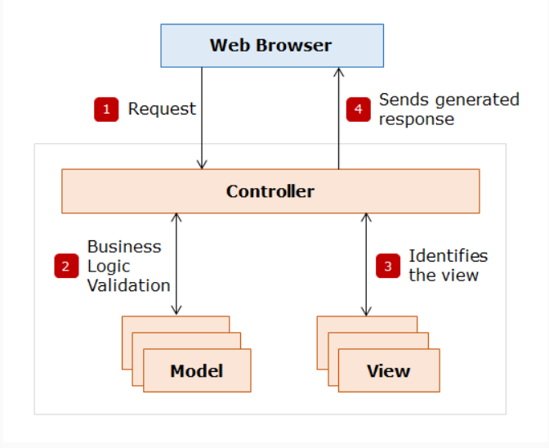

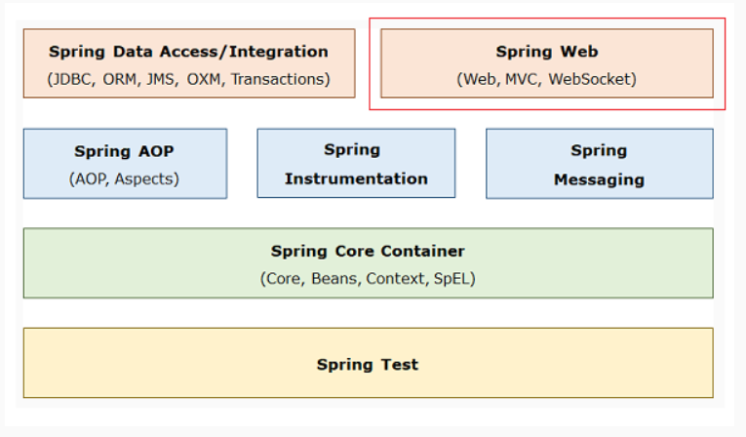

It has following features:
- It is a subproject of Spring. So, it provides all Spring's core features such as dependency injection and annotations.
- It provides a mechanism to extract data from user request and mapping it to a model class to construct an object which makes development easy and simple.
- It is view independent. You can use any technology for generating the view such as JSP, Tiles, Theamleaf etc.
- It is action-based framework. Every user request is an action to be performed with the framework. This is achieved by mapping each request to an executable method. The request parameters are also mapped to arguments of this method.
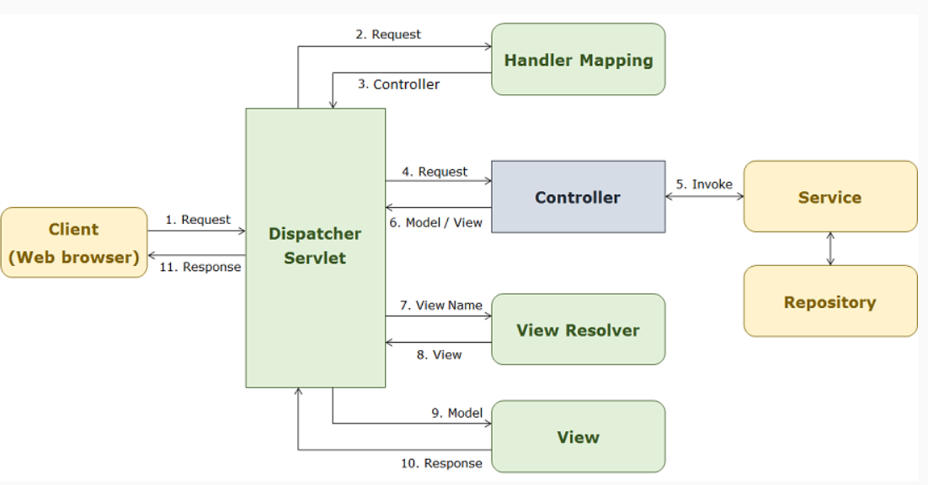

- The DispatcherServlet intercepts the incoming HTTP request.
- An application can have multiple controllers so the DispatcherServlet interacts with handler mapping to decide which controller to send the request.
- The handler mapping uses the request URL to decide which controller to send the request and sends controller information to DispatcherServlet.
- After receiving the appropriate controller name, DispatcherServlet sends the request to the controller.
- The controller receives the request from the DispatcherServlet and performs business logic.
- After the business logic is performed by the controller, it generates some data that needs to be sent back to the client and displayed in a web browser. This information is called a model. So, the controller sends the model and logical name of the view to the DispatcherServlet.
- The DispatcherServlet passes the logical view name to a ViewResolver, which determines the actual view.
- The actual view is sent back to DispatcherServlet.
- The DispatcherServlet then passes the model to the View, which generates a response.
- The generated response is sent back to DispatcherServlet.
- The DispatcherServlet returns the generated response over to the client.
Note that, by default, DispatcherServlet supports GET, HEAD, POST, PUT, PATCH and DELETE HTTP methods only.
Dispatcher servlet is the front controller to accept request from browser [ / ]. It knows which path is mapped to which method in RestController class. Once processed the dispatcher servlet send response back to browser using RestController annotation which has response body defined in it. The response body then convert it into JSON with help of JacksonAutoConfiguration ( it converts bean to JSON and JSON to bean).

